***Queen Bee Aerial Specialties***

***Ag Spray Equipment***

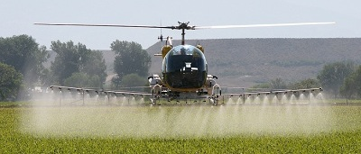

#### Thank you to our Sponsors:

Phone: 970-217-5293

Lamar Municipal Airport (KLAA)

3652 Cnty Rd GG.2

Lamar, CO 81052

(719) 336-7701

Colorado Agricultural Aviation Association

# Operation S.A.F.E Fly-in

October 2-3, 2019

**Colorado Agricultural Aviation Association, Inc. (CoAAA)**





16489 Burghley Ct.

Platteville, CO 80651

Phone: 970-217-5293

[coagav@gmail.com](mailto:coagav@gmail.com)

www.coagav.org

# Thursday October 3, 2019

**6:00 am**

Breakfast provided by:

* Set up Flight line

**7:30 am**

Fly-in Begins

**8:00 am**

First Responders Training Begins

**Station 1**

* Pilot Briefing
* Overseeing load operations

Loading Equipment provided by: ***Jet Stream Ag Aviation Inc.***

**Station 2**

* Flight Line Duties
* Drift Tower Operation

**Station 3**

* String Analysis
* DropletScan Analysis
* Print out and Pilot Consultation

**12:00 p.m.**

Lunch

**1:00 p.m.**

Fly-in Resumes

For Fly-In participation on either Wednesday or Thursday.

**Colorado CEU’s Available**

**Kansas CEU’s Available**

***Beverages Provided By:***

#### Fly-In Schedule 2019

PARTICIPANTS MUST BRING PROOF OF AIRCRAFT INSURANCE.

AIRCRAFT MUST BE CLEANED AND NEUTRALIZED. FREE FROM ANY RESIDUE OR ODORS PRIOR TO ATTENDING FLY-IN

# Wednesday October 2, 2019

**6:00 am**

Breakfast provided by: ***Colorado Agricultural Aviation Association***

* Set up flight line

**7:30 am**

Fly-in begins

**Station 1**

* Pilot Briefing
* Overseeing Load Operations

Loading Equipment provided by:

***Air Care, Inc.***

**Station 2**

* Flight Line Duties
* Drift Tower Operation

**Station 3**

* String Analysis
* Droplet Scan Analysis
* Print out and Pilot Consultation

**11:00 A.M.**

Pattern, Uniformity, and Drift Mitigation presented by Alan Corr

**12:00 pm**

Lunch provided by:

***Queen Bee Aerial Specialties***

**2:00 p.m.**

Fly-in Resumes

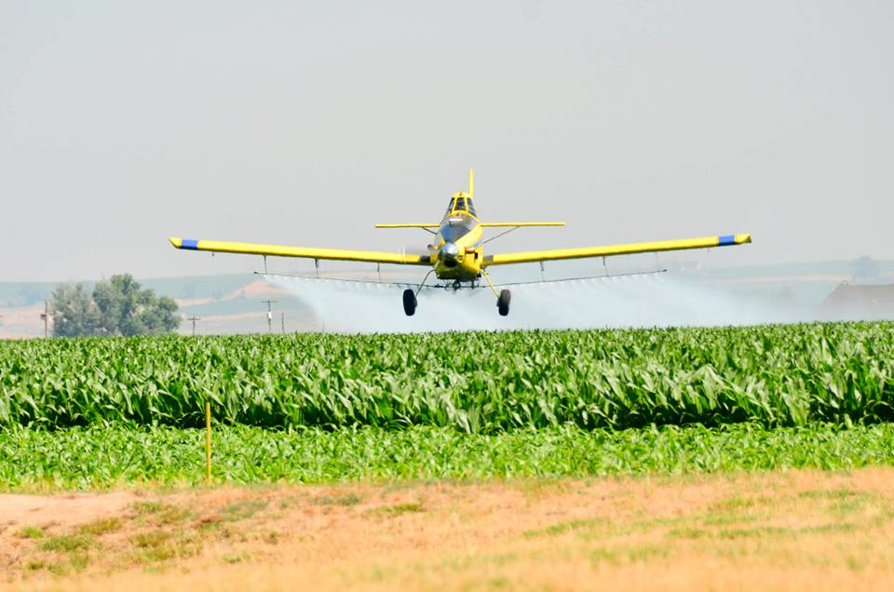

*All participants must bring proof of Aircraft insurance*

